1. Default or current quantity does not show in the qty editor
2. Appears to be showing the same order repeated
3. Payment editor button not working
4. Processing editor button not working
5. Shipping address editor not working
6. Ship method editor button not working
7. Remove button not working
8. Should Page header be AutoShip Preferences? Perhaps should say “Your Autoships” and then have “Preferences” and / or ‘Update” labels as appropriate?
9. Should results be paged ?
10. Should the side navigation be added back in from Travis’ BackOffice for toggling between Current AutoShips and Past / Cancelled AutoShips?

Backoffice – Commissions

Volumes page – instead of PCV, PBV, and GCV the labels are generically numbered…is this on purpose since the Volume buckets change? Under the Organization page and Volume tab the labels show correctly.

Commissions – Volume Screenshot

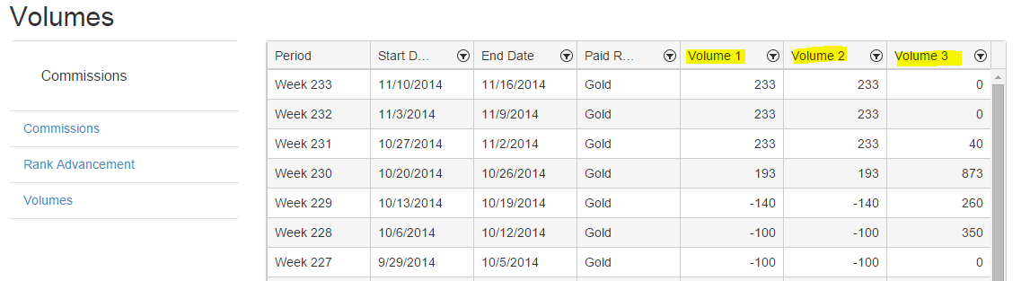

Organization – Volume Tab

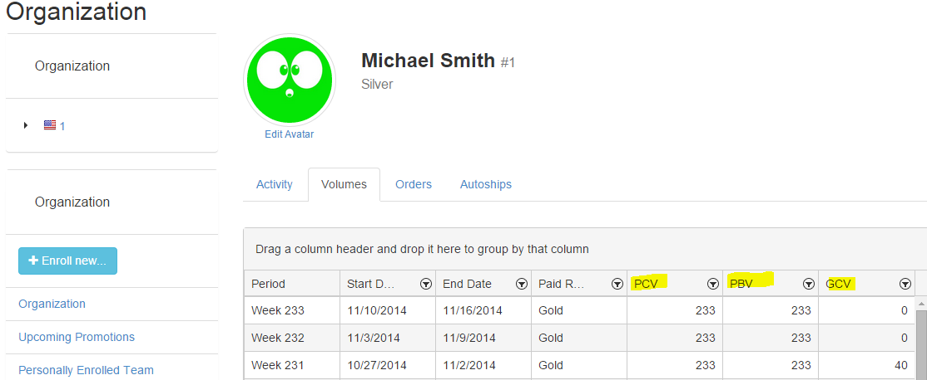

Also a legend for the volume Bucket acronyms might be helpful to a user

The need for legend could also be applied on the Orders and Autoships tabs under Organization

Organization – The Reports

Just a preference, but I would think it better to set all of these to display a default message in place of the empty Kendo grid if there are no items / customers to display

Calendar – Subscription

Under the Add Subscription, the search button is faded out a bit too much and hard to see

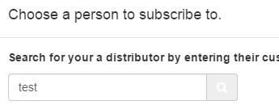

It highlights blue on hover but perhaps a different color or less opacity when not hovered would be better

Resources

A lock icon on the menu or hiding the Manage link from the dropdown navigation, and condition to check for the user permissions might be a good idea to add to the starting framework as we will have to do this during implementation as well

Additionally – the Actions column in the library needs something to go there if the user does not have permission to manage or needs to be labeled differently and replaced based on whether they are a distributor or a corporate admin

Store

Several of our clients, including ACN and Pangea have had us add in a quick shop button when the user / customer hovers on the product image and a popup to add the item to the cart appears if the button is clicked.

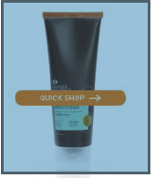

The other option is for the user to click on the image and be taken to the product detail page. Note: Currently on the image is the link to the product detail page – perhaps the product name / description should be linked as well or include a button that says “View Item” This could also be a great thing to add into the Replicated site shopping